# **Capstone Project - The Battle of Neighborhoods**

# Where do we get good Briyani?

## Introduction

I have been main places and tried variety of food but at end of the day briyani is the special for me and my Asian friends irrespective of how many times you eat. So I want to find the best briyani place in USA. The problem is to solve the Briyani places in the major cities and find the best place for Asian friends so that they can have a spicy briyani.

## Data section

I will use FourSquare API to collect the data of Briyani places locations in 5 cities which are: New York, San Francisco, Jersey City, Boston & Chicago. These are the big cities and hope that it will have the best briyani.

## Methodology

The Idea is to assess the cities in which have the best briyani place. I used Four Square API through the venues channel. I used the near query to get venues in the cities. Also, I use the CategoryID to set it to show only briyani Places. An Example of my requests:

https://api.foursquare.com/v2/venues/explore?&client_id=&client_secret=&v=20180605&New York &limit=100&categoryId=4bf58dd8d48988d1ca941735

4bf58dd8d48988d1ca941735 is the Id of the Briyani Place Category. Foursquare limits to allow maximum of 100 venues per query.

Moreover, I repeated this request for 5 cities and got the top 100 venues. I saved the name and coordinate data only from the result and plotted them on the map for visual inspection.

Next, to get an indicator of the density of Briyani Places, I calculated a center coordinate of the venues to get the mean longitude and latitude values. Then I calculated the mean of the Euclidean distance from each venue to the mean coordinates. That was my indicator; mean distance to the mean coordinate.

## Results

For our initial visual inspection we see that they all have multiple briyani places and often more than Foursquare would like to supply us. The following here are the pictures of the geoplot generated with folium:

#### New York:

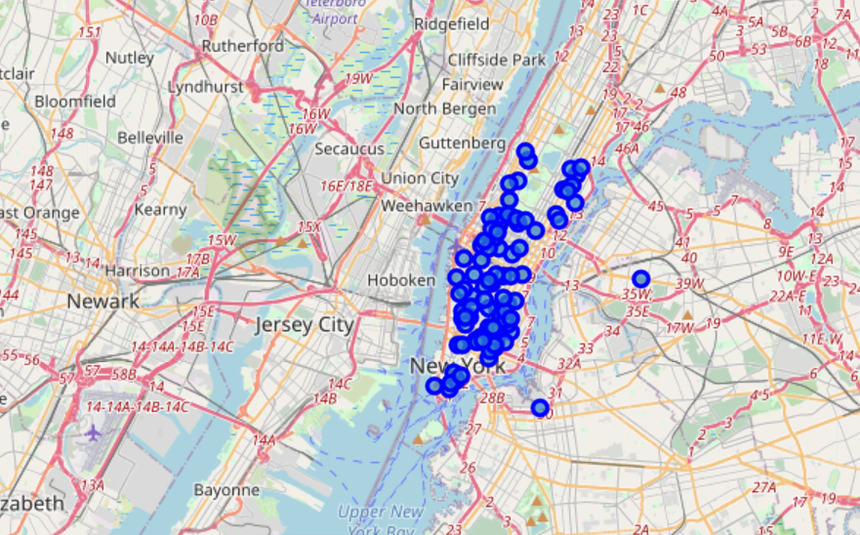

#### Chicago:

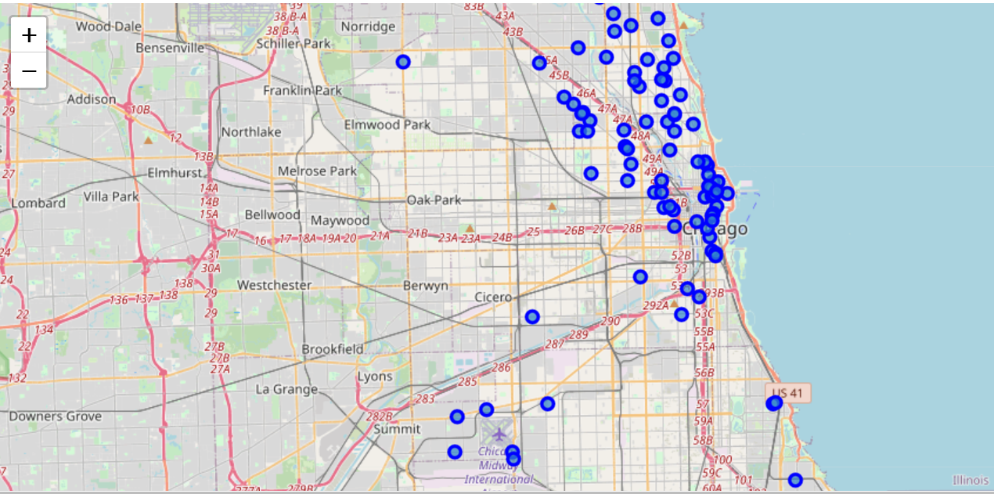

#### San Francisco:

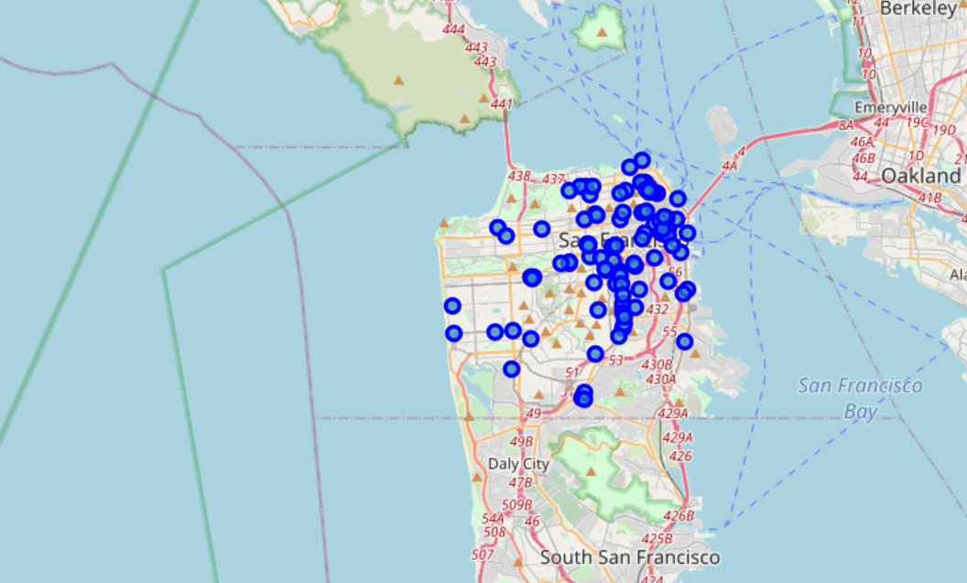

#### Jersey City:

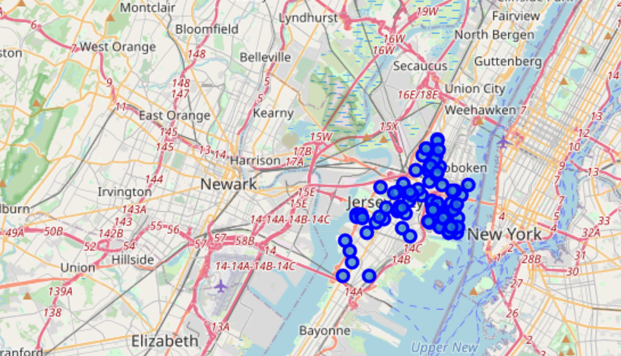

#### Boston:

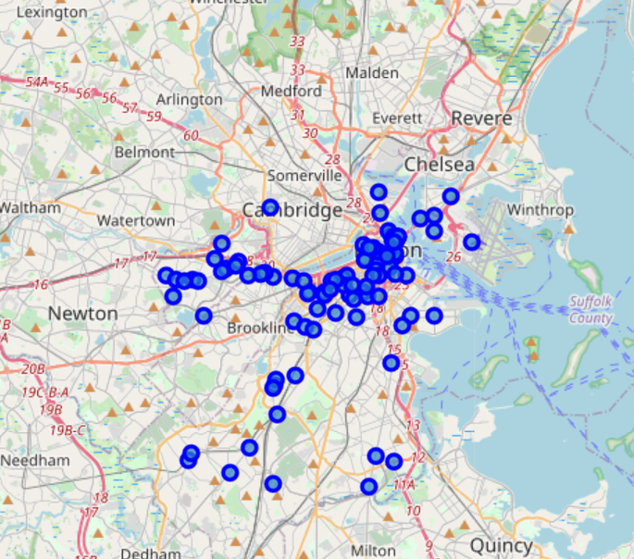

Upon First inspection we see that New York, Jersey City and San Francisco are the most densely cities. In the next phase we Calculate the Mean coordinate and the mean distance to mean coordinate(MDMC). We represent the mean coordinate with a big green circle and distances with green lines

#### New York:

MDMC: 0.021556

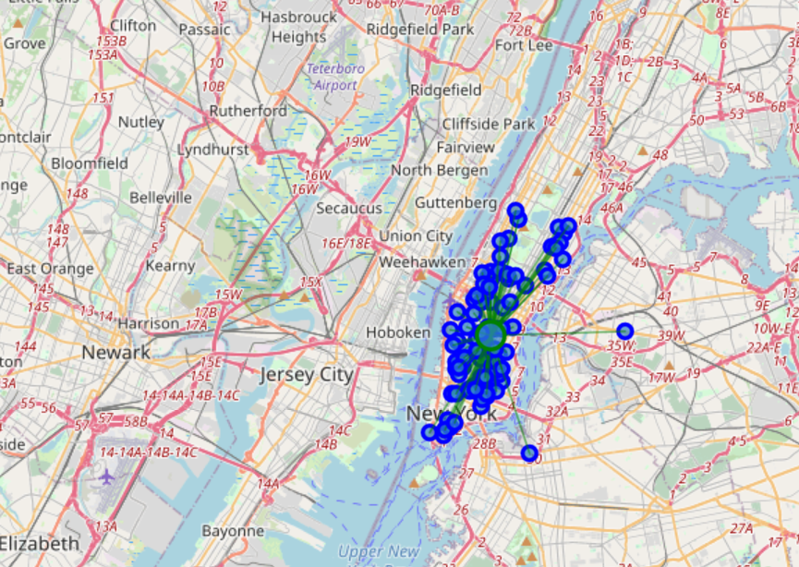

#### Chicago:

MDMC: 0.052805

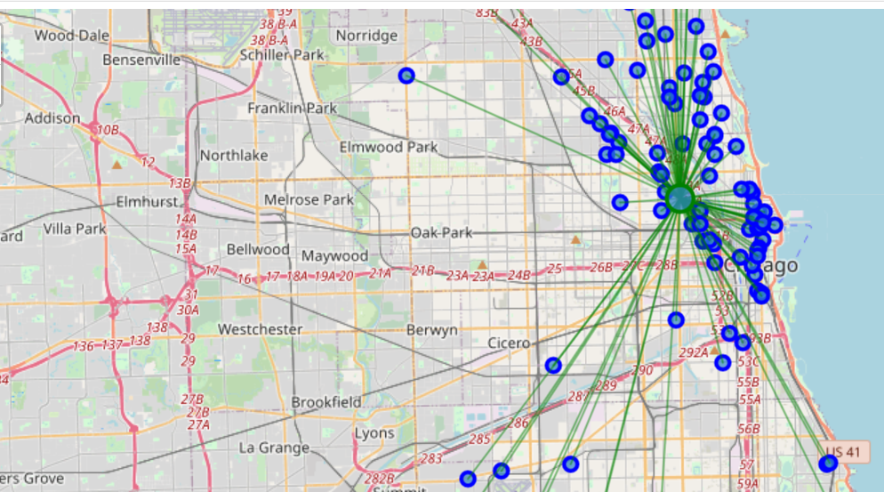

#### San Francisco:

MDMC: 0.028633

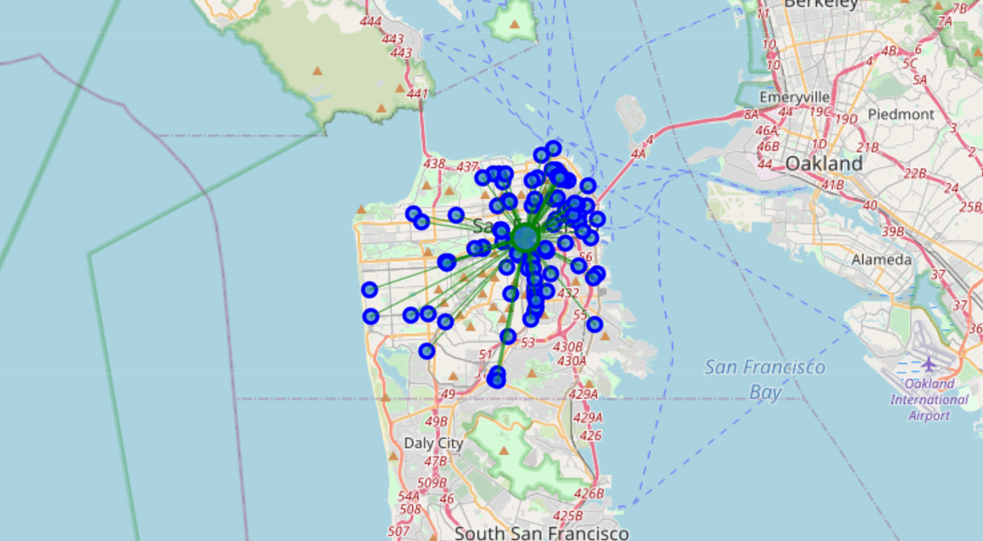

#### Jersey City:

MDMC: 0.029950

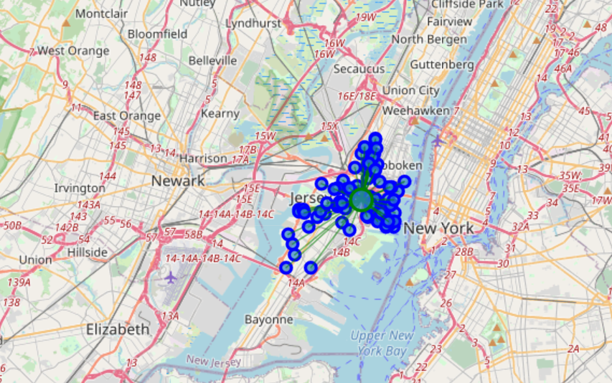

#### Boston:

MDMC: 0.035126

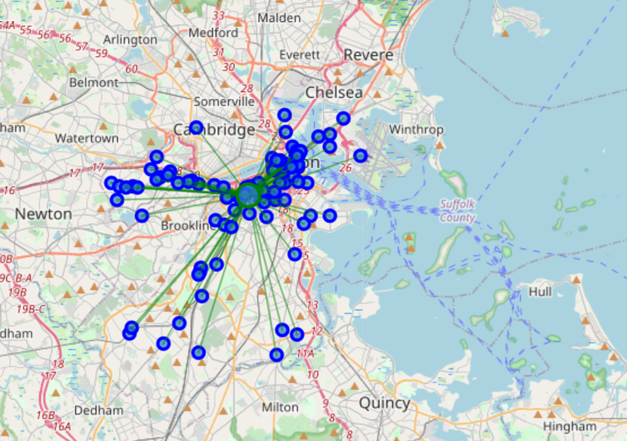

The outputs are :

* New York
* San Francisco
* Jersey City
* Boston
* Chicago

## Discussion:

One thing I noticed in here that there is a really far away briyani places in Jersey City that is probably giving it a higher MDMC. So I checked what if I removed it, it would not harm anyone to try 99 briyani places than 100 and New York is just at the other shore.

The new MDMC was: 0.0219953, putting it one place up on the list replacing San Francisco.

One consideration to do further work on is to move the location of the Foursquare API query until we get all the briyani places in each city and do the calculations again.

## Conclusion:

There is no doubt that New York is the best place to try many briyani Also, if I’m done with all the New York briyani places, I can drive to Jersey City and enjoy 99 more.

Also, i would recommend to book the hotel close to the mean coordinate.